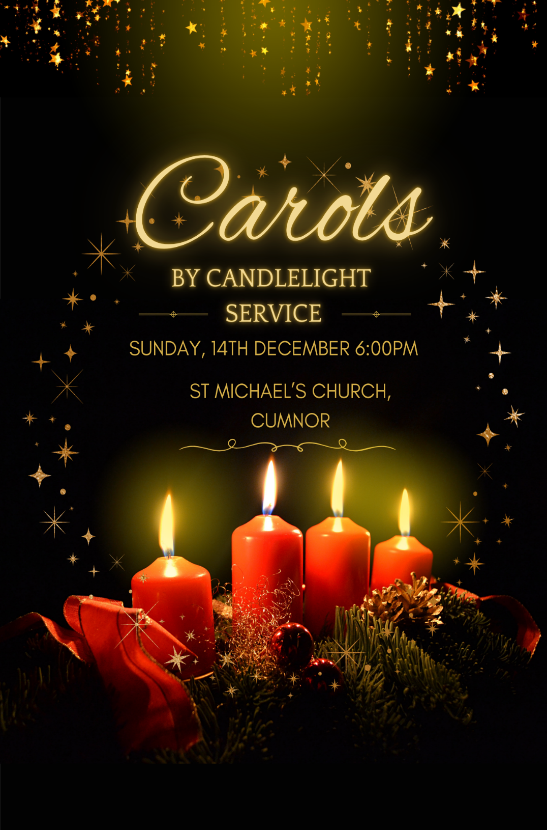
Welcome and Introduction

Welcome to St Michael’s for this celebration of the Christmas story in word, hymns and carols. The order we are following is traditional; its purpose is to tell the story of God making himself known to humankind.

It begins with the tale of the archetypal Man and Woman, their disregard of God’s guidance for a fully human life, and his calling to the patriarch Abraham and his descendants, to be a blessing to all humanity.

When they lost sight of that calling, God Himself broke into our world, coming as one of us – Jesus, ‘the ‘Human Face of God’, as one writer has described Him.

That is what tonight’s service is all about. God in Christ is the focus of our thoughts at this time. ‘He came down to Earth from Heaven…’

So it is our hope that these familiar words, stories and songs will bring you fresh faith and hope, as together we remember God’s astonishing generosity towards us, and look ahead to all He continues to set before us.

There will be no announcements or sermon in this service – this whole combination of carols, hymns and readings speak more powerfully than any one of us could…

So let’s enjoy this evening together – and ‘thanks be to God’!

ONCE IN ROYAL DAVID’S CITY

(Solo) Stood a lowly cattle shed,
Where a mother laid her Baby,
In a manger for His bed:
Mary was that mother mild,
Jesus Christ, her little Child.

(All) He came down to earth from heaven,
Who is God and Lord of all,
And His shelter was a stable,
And His cradle was a stall:
With the poor, and mean, and lowly,
Lived on earth our Saviour holy.

And our eyes at last shall see Him,
Through His own redeeming love;
For that Child so dear and gentle,
Is our Lord in heaven above:
And He leads His children on,
To the place where He is gone.

Not in that poor lowly stable,
With the oxen standing by,
We shall see him; but in heaven,
Set at God's right hand on high;
Where like stars his children crowned,
All in white, shall wait around.

Bidding Prayer

Beloved in Christ, be it this Christmastide our care and delight to hear again the message of the angels, and in heart and mind to go even unto Bethlehem and see this thing which is come to pass, and the Babe lying in a manger.
Therefore let us read and mark in Holy Scripture the tale of the loving purposes of God from the first days of our disobedience unto the glorious redemption brought us by this Holy Child.
But first, let us pray for the needs of the whole world; for peace on earth and goodwill among all his people; for unity and brotherhood within the Church he came to build, and especially in this community of Cumnor, and city and diocese of Oxford.
And because this of all things would rejoice his heart, let us remember, in his name, the poor and helpless, the cold, the hungry and the oppressed; the sick and them that mourn, the lonely and the unloved, the aged and the little children; all those who know not the Lord Jesus, or who love him not, or who by sin have grieved his heart of love.
Lastly, let us remember before God all those who rejoice with us, but upon another shore, and in a greater light, that multitude which no one can number, whose hope was in the Word made flesh, and with whom in the Lord Jesus we are for ever one.
These prayers and praises let us humbly offer up to the throne of heaven, in the words which Christ himself has taught us:

(All) Our Father, which art in heaven,
hallowed be thy name;
thy kingdom come;
thy will be done,
in earth as it is in heaven.
Give us this day our daily bread.
And forgive us our trespasses,
as we forgive them that trespass against us.
And lead us not into temptation;
but deliver us from evil.
For thine is the kingdom,
the power and the glory,
for ever and ever.
Amen.



Genesis 3.8-14 read by Karen Adamson

Adam and his wife heard the voice of the Lord God walking in the garden in the cool of the day: and they hid themselves from the presence of the Lord God amongst the trees of the garden.
And the Lord God called Adam, and said to him, Where are you?
And he said, I heard your voice in the garden, and I was afraid, because I was naked; and I hid myself.
And he said, Who told you that you were naked? Have you eaten of the tree, whereof I commanded you that you should not eat?
And the man said, The woman whom you gave to be with me, she gave me of the tree, and I did eat.
And the Lord God said to the woman, What is this that you have done? And the woman said, The serpent beguiled me, and I did eat.
And the Lord God said to the serpent, Because you have done this, you are cursed above all cattle, and above every beast of the field; upon your belly shall you go, and dust shall you eat all the days of your life:
And I will put enmity between you and the woman, and between your seed and her seed; it shall bruise your head, and you shall bruise his heel.

For the Word of the Lord,
Thanks be to God

(Choir) What Sweeter Music

What sweeter music can we bring
Than a carol, for to sing
The birth of this our heavenly King?
Awake the voice! Awake the string!
Dark and dull night, fly hence away,
And give the honour to this day,
That sees December turned to May.
That sees December turned to May.
Why does the chilling winter's morn
Smile, like a field beset with corn?
Or smell like a meadow newly-shorn,
Thus, on the sudden? Come and see
The cause, why things thus fragrant be:
'Tis He is born, whose quickening birth
Gives life and lustre, public mirth,
To heaven, and the under-earth.
We see him come, and know him ours,
Who, with his sunshine and his showers,
Turns all the patient ground to flowers.
Turns all the patient ground to flowers.
The darling of the world is come,
And fit it is, we find a room
To welcome him. To welcome him.
The nobler part Of all the house here,
is the heart.
Which we will give him; and bequeath
This holly, and this ivy wreath,
To do him honour, who's our King,
And Lord of all this revelling.
What sweeter music can we bring,
Than a carol for to sing
The birth of this our heavenly King?

Genesis 22.15-18 read by David Clapton

The angel of the Lord called to Abraham a second time from heaven, and said, ‘By myself I have sworn, says the Lord: Because you have done this, and have not withheld your son, your only son, I will indeed bless you, and I will make your offspring as numerous as the stars of heaven and as the sand that is on the seashore. And your offspring shall possess the gate of their enemies, and by your offspring shall all the nations of the earth gain blessing for themselves, because you have obeyed my voice.’

For the Word of the Lord,
Thanks be to God



(All) In the bleak midwinter
Frosty wind made moan;
Earth stood hard as iron,
Water like a stone.
Snow had fallen, snow on snow,
Snow on snow;
In the bleak midwinter,
Long ago.

Our God, heaven cannot hold Him,
Nor earth sustain,
Heaven and earth shall flee away
When He comes to reign.
In the bleak midwinter
A stable-place sufficed
The Lord God Almighty,
Jesus Christ.

Angels and archangels
May have gathered there,
Cherubim and seraphim
Thronged the air.
But only His mother,
In her maiden bliss,
Worshipped the Belovèd
With a kiss.

What can I give Him,
Poor as I am?
If I were a shepherd,
I would bring a lamb.
If I were a wise man,
I would do my part;
Yet what I can I give Him-
Give my heart.

(Choir) Bethlehem Down

"When He is King we will give him the Kings' gifts,
Myrrh for its sweetness, and gold for a crown,
Beautiful robes," said the young girl to Joseph,
Fair with her first-born on Bethlehem Down.

Bethlehem Down is full of the starlight,
Winds for the spices, and stars for the gold,
Mary for sleep, and for lullaby music
Songs of a shepherd by Bethlehem fold.
When he is King they will clothe him in grave-sheets,
Myrrh for embalming and wood for a crown,
He that lies now in the white arms of Mary
Sleeping so lightly on Bethlehem Down.

Here he has peace and a short while for dreaming,
Close-huddled oxen to keep him from cold,
Mary for love, and for lullaby music
Songs of a shepherd by Bethlehem fold.

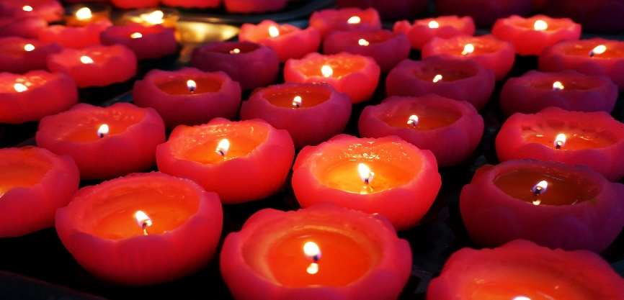

Isaiah 9.2, 6-7 read by Kate Elliott

The people who walked in darkness
have seen a great light;
those who lived in a land of deep darkness—
on them light has shined.
For a child has been born for us,
a son given to us;
authority rests upon his shoulders;
and he is named
Wonderful Counsellor, Mighty God,
Everlasting Father, Prince of Peace.
His authority shall grow continually,
and there shall be endless peace
for the throne of David and his kingdom.
He will establish and uphold it
with justice and with righteousness
from this time onwards and for evermore.
The zeal of the Lord of hosts will do this.

For the Word of the Lord,
Thanks be to God


(Choir) Gold for a Manger Bed

Gold for a manger bed,
Jesus enshrining;
straw where he lays his head,
softly reclining;
so small and still he lies
as on his infant eyes
high in the darkened skies
the stars are shining.

King and Creator see,
whose hands have wrought us;
Saviour and Shepherd he,
who loved and sought us;
our God in human frame
who to a lost world came
and on the cross of shame
so dearly bought us.

Gold for a monarch's state,
all things sustaining;
High Prince and Potentate,
death's dread disdaining;
to him the ransomed raise
unceasing songs of praise,
through everlasting days
in glory reigning.

Micah 5.2-4 read by Malcolm Taylor

But you, O Bethlehem of Ephrathah,
who are one of the little clans of Judah,
from you shall come forth for me
one who is to rule in Israel,
whose origin is from of old,
from ancient days.
Therefore he shall give them up until the time
when she who is in labour has brought forth;
then the rest of his kindred shall return
to the people of Israel.
And he shall stand and feed his flock in the strength of the Lord,
in the majesty of the name of the Lord his God.
And they shall live secure, for now he shall be great
to the ends of the earth.

For the Word of the Lord,
Thanks be to God

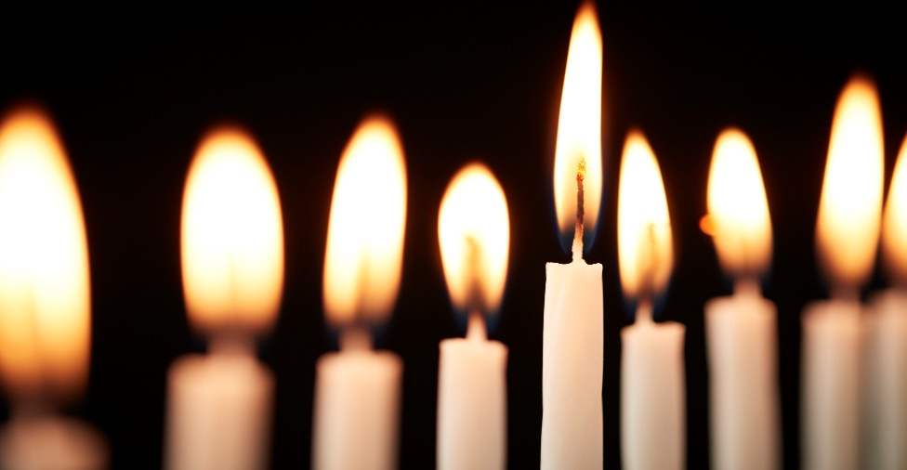
(All) O little town of Bethlehem
How still we see thee lie
Above thy deep and dreamless sleep
The silent stars go by
Yet in thy dark streets shineth
The everlasting Light
The hopes and fears of all the years
Are met in thee tonight.

O morning stars together
Proclaim the holy birth
And praises sing to God the King
And Peace to men on earth
For Christ is born of Mary
And gathered all above
While mortals sleep, the angels keep
Their watch of wondering love

How silently, how silently
The wondrous gift is giv’n!
So God imparts to human hearts
The blessings of His heav’n.
No ear may hear His coming,
But in this world of sin,
Where meek souls will receive him, still
The dear Christ enters in.

O holy Child of Bethlehem
Descend to us, we pray
Cast out our sin and enter in
Be born in us today
We hear the Christmas angels
The great glad tidings tell
O come to us, abide with us
Our Lord Emmanuel.

Luke 1.26-38 read by Jenny Dyer

In the sixth month the angel Gabriel was sent by God to a town in Galilee called Nazareth, to a virgin engaged to a man whose name was Joseph, of the house of David. The virgin’s name was Mary. And he came to her and said, ‘Greetings, favoured one! The Lord is with you.’

But she was much perplexed by his words and pondered what sort of greeting this might be. The angel said to her, ‘Do not be afraid, Mary, for you have found favour with God. And now, you will conceive in your womb and bear a son, and you will name him Jesus. He will be great, and will be called the Son of the Most High, and the Lord God will give to him the throne of his ancestor David. He will reign over the house of Jacob for ever, and of his kingdom there will be no end.’

Mary said to the angel, ‘How can this be, since I am a virgin?’ The angel said to her, ‘The Holy Spirit will come upon you, and the power of the Most High will overshadow you; therefore the child to be born will be holy; he will be called Son of God.

And now, your relative Elizabeth in her old age has also conceived a son; and this is the sixth month for her who was said to be barren. For nothing will be impossible with God.’ Then Mary said, ‘Here am I, the servant of the Lord; let it be with me according to your word.’ Then the angel departed from her.

For the Word of the Lord,
Thanks be to God
(Choir) Mary had a Baby

Mary had a baby, oh, Lord,
Mary had a baby, oh my Lord,
Mary had a baby, oh Lord,
People keep a-comin' an' the train done gone.

Matthew 1.10-23 read by Sharon Green

Now the birth of Jesus the Messiah took place in this way. When his mother Mary had been engaged to Joseph, but before they lived together, she was found to be with child from the Holy Spirit. Her husband Joseph, being a righteous man and unwilling to expose her to public disgrace, planned to dismiss her quietly. But just when he had resolved to do this, an angel of the Lord appeared to him in a dream and said, ‘Joseph, son of David, do not be afraid to take Mary as your wife, for the child conceived in her is from the Holy Spirit. She will bear a son, and you are to name him Jesus, for he will save his people from their sins.’ All this took place to fulfil what had been spoken by the Lord through the prophet:
‘Behold, a virgin shall conceive and bear a son,
and they shall name him Emmanuel’,
which means, ‘God is with us.’

For the Word of the Lord,
Thanks be to God

(All) O Come, all ye faithful

O come, all ye faithful,
Joyful and triumphant!
O come ye, O come ye to Bethlehem;
Come and behold him
Born the King of Angels:

O come, let us adore Him,
O come, let us adore Him,
O come, let us adore Him,
Christ the Lord.

God of God,
Light of Light,
Lo, he abhors not the Virgin’s womb;
Very God,
Begotten, not created: O come…

See how the shepherds summoned to his cradle,
Leaving their flocks,
Draw nigh with lowly fear;
we too will thither
bend our joyful footsteps: O come…

Sing, choirs of angels,
Sing in exultation,
Sing, all ye citizens of Heaven above!
Glory to God
In the highest: O come…

Luke 2.8-16 read by David Henderson Slater

In that region there were shepherds living in the fields, keeping watch over their flock by night. Then an angel of the Lord stood before them, and the glory of the Lord shone around them, and they were terrified. But the angel said to them, ‘Do not be afraid; for see—I am bringing you good news of great joy for all the people: to you is born this day in the city of David a Saviour, who is the Messiah, the Lord. This will be a sign for you: you will find a child wrapped in bands of cloth and lying in a manger.’
And suddenly there was with the angel a multitude of the heavenly host, praising God and saying,
‘Glory to God in the highest heaven,
and on earth peace among those whom he favours!’
When the angels had left them and gone into heaven, the shepherds said to one another, ‘Let us go now to Bethlehem and see this thing that has taken place, which the Lord has made known to us.’ So, they went with haste and found Mary and Joseph, and the child lying in the manger.

For the Word of the Lord,
Thanks be to God

(All) See, amid the winter’s snow,
born for us on earth below,
see the tender Lamb appears,
promised from eternal years.
Hail, thou ever blessed morn!
Hail, redemption's happy dawn!
Sing through all Jerusalem,
"Christ is born in Bethlehem."

Lo, within a manger lies
He who built the starry skies;
He who, throned in height sublime,
sits amid the cherubim!

Say, ye holy shepherds, say,
what's your joyful news today?
Wherefore have ye left your sheep
on the lonely mountain steep?

"As we watched at dead of night,
Lo! we saw a wondrous light;
angels singing 'Peace on earth'
told us of the Saviour's birth."

Sacred Infant, all divine,
what a tender love was Thine,
thus to come from highest bliss
down to such a world as this!

Teach, O teach us, Holy Child,
by Thy face so meek and mild,
teach us to resemble Thee,
in Thy sweet humility!
Matthew 2.1-11 read by Claire Horsman

In the time of King Herod, after Jesus was born in Bethlehem of Judea, wise men from the East came to Jerusalem, asking, ‘Where is the child who has been born king of the Jews? For we observed his star at its rising, and have come to pay him homage.’ When King Herod heard this, he was frightened, and all Jerusalem with him; and calling together all the chief priests and scribes of the people, he inquired of them where the Messiah was to be born. They told him, ‘In Bethlehem of Judea; for so it has been written by the prophet:
‘And you, Bethlehem, in the land of Judah,
are by no means least among the rulers of Judah;
for from you shall come a ruler
who is to shepherd my people Israel.’
Then Herod secretly called for the wise men and learned from them the exact time when the star had appeared. Then he sent them to Bethlehem, saying, ‘Go and search diligently for the child; and when you have found him, bring me word so that I may also go and pay him homage.’ When they had heard the king, they set out; and there, ahead of them, went the star that they had seen at its rising, until it stopped over the place where the child was. When they saw that the star had stopped, they were overwhelmed with joy.
On entering the house, they saw the child with Mary his mother; and they knelt down and paid him homage. Then, opening their treasure-chests, they offered him gifts of gold, frankincense, and myrrh.
For the Word of the Lord,
Thanks be to God

(Choir) Angel Tidings, Shepherd’s Farewell

Thou must leave Thy lowly dwelling,
The humble crib, the stable bare.
Babe, all mortal babes excelling,
Content our earthly lot to share.
Loving father, Loving mother,
Shelter Thee with tender care!
Blessed Jesus, we implore Thee
With humble love and holy fear.
In the land that lies before Thee,
Forget not us who linger here!
May the shepherd's lowly calling,
Ever to Thy heart be dear!
Blest are ye beyond all measure,
Thou happy father, mother mild!
Guard ye well your heav'nly treasure,
The Prince of Peace, The Holy Child!
God go with you, God protect you,
Guide you safely through the wild!



John 1.1-14 read by John Rees

In the beginning was the Word, and the Word was with God, and the Word was God. He was in the beginning with God. All things came into being through him, and without him not one thing came into being. What has come into being in him was life, and the life was the light of all people. The light shines in the darkness, and the darkness did not overcome it.
There was a man sent from God, whose name was John. He came as a witness to testify to the light, so that all might believe through him. He himself was not the light, but he came to testify to the light. The true light, which enlightens everyone, was coming into the world.
He was in the world, and the world came into being through him; yet the world did not know him. He came to what was his own, and his own people did not accept him. But to all who received him, who believed in his name, he gave power to become children of God, who were born, not of blood or of the will of the flesh or of the will of man, but of God.
And the Word became flesh and lived among us, and we have seen his glory, the glory as of a father’s only son, full of grace and truth.

For the Gospel of the Lord,
Thanks be to God

(All) Hark! The herald angels sing

Hark! the herald angels sing
"Glory to the newborn King!
Peace on earth and mercy mild
God and sinners reconciled"
Joyful, all ye nations rise
Join the triumph of the skies
With the angelic host proclaim:
"Christ is born in Bethlehem"
Hark! The herald angels sing
"Glory to the newborn King!"

Christ by highest heav'n adored
Christ the everlasting Lord!
Late in time behold Him come
Offspring of a virgin's womb
Veiled in flesh the Godhead see
Hail the incarnate Deity
Pleased as man with man to dwell
Jesus, our Emmanuel
Hark! The herald angels sing
"Glory to the newborn King!”

Hail the heav'n-born Prince of Peace!
Hail the Sun of Righteousness!
Light and life to all He brings
Risen with healing in His wings
Mild He lays His glory by
Born that man no more may die
Born to raise the sons of earth
Born to give them second birth
Hark! The herald angels sing
"Glory to the newborn King!”

(Minister) May the joy of the angels,
the eagerness of the shepherds,
the perseverance of the wise men,
the obedience of Joseph and Mary,
and the peace of the Christ-Child
be yours this Christmas;
and the blessing of God Almighty,
the Father, the Son, and the Holy Spirit
be among you and remain with you always. Amen

