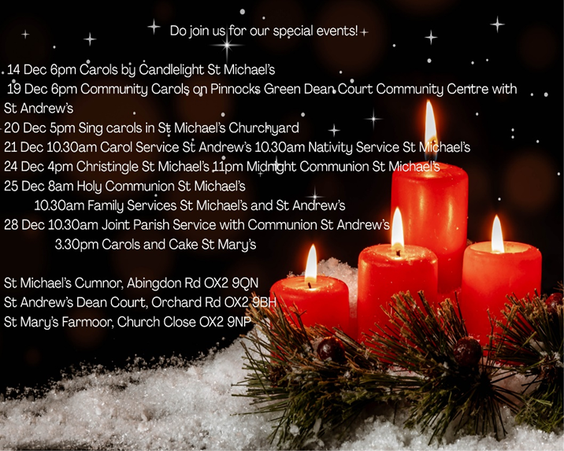

St Michael’s Church, Cumnor
Morning Worship (Advent 3)
Sunday 14th December 2025

Welcome & call to worship
‘In the wilderness prepare the way for the Lord,
make straight in the desert a highway for our God.
And the glory of the Lord will be revealed,
and all people will see it together.
For the mouth of the Lord has spoken.’ (Isaiah 40 3,5)

Hymn 401: On Jordan’s bank

Lighting the Advent Candles
The first two candles are re-lit.
Today we remember the John the Baptist who called God’s people to repent and prepared the way for the coming of God’s chosen Messiah.

The third candle is lit and then we pray:

Lord Jesus, light of the world,
John told the people to prepare,
for you were very near.
As Christmas grows closer day by day,
help us to be ready to welcome you now. Amen.

Prayers of Forgiveness
Jesus says, ‘Repent, for the kingdom of heaven is close at hand.’ So let us turn away from our sin and turn to Christ, confessing our sins in penitence and faith.

All: Lord God, we have sinned against you;
we have done evil in your sight.
We are sorry and repent.
Have mercy on us according to your love.
Wash away our wrongdoing and cleanse us from our sin.
Renew a right spirit within us
and restore us to the joy of your salvation;
through Jesus Christ our Lord. Amen.

May the Father of all mercies
cleanse you from your sins,
and restore you in his image
to the praise and glory of his name,
through Jesus Christ our Lord.
All Amen.

The Benedictus (The Song of Zechariah, Luke 1.68–79)

1 Blessed be the Lord the God of Israel,
who has come to his people and set them free.
2 He has raised up for us a mighty Saviour,
born of the house of his servant David.

Closing Prayer
Emmanuel, our broken world waits for you.
In the darkness of winter, we choose hope.
Trusting in your promise to bless us with your light,
we proclaim,
“Our God draws near.”
God of goodness and love,
we thank you for your promises.
We welcome your coming into our lives,
and we commit ourselves
to be a means of your coming to those in need.
We offer this prayer in Jesus’ name, Amen.

The Blessing
Christ the Sun of Righteousness shine upon you,
scatter the darkness from before your path,
and make you ready to meet him when he comes in glory;
and the blessing of God Almighty, the Father, the Son and the Holy Spirit be among you and with all those you love and those for whom you pray and remain with you always. Amen

Hymn 329: Make way, make way
The Collect:
O Lord Jesus Christ,
who at your first coming sent your messenger
to prepare your way before you:
grant that the ministers and stewards of your mysteries
may likewise so prepare and make ready your way
by turning the hearts of the disobedient to the wisdom of the just,
that at your second coming to judge the world
we may be found an acceptable people in your sight;
for you are alive and reign with the Father
in the unity of the Holy Spirit,
one God, now and for ever. Amen.

The Lord’s Prayer
Gathering our prayers and praises into one,
as our Saviour has taught us, so we pray:
Our Father in heaven, hallowed be your name,
your kingdom come, your will be done,
on earth as in heaven.
Give us today our daily bread.
Forgive us our sins
as we forgive those who sin against us.
Lead us not into temptation
but deliver us from evil.
For the kingdom, the power,
and the glory are yours, now and for ever. Amen

3 Through his holy prophets God promised of old
to save us from our enemies,
from the hands of all that hate us,
4 To show mercy to our ancestors,
and to remember his holy covenant.
5 This was the oath God swore to our father Abraham:
to set us free from the hands of our enemies,
6 Free to worship him without fear,
holy and righteous in his sight all the days of our life.
7 And you, child, shall be called the prophet of the Most High,
for you will go before the Lord to prepare his way,
8 To give his people knowledge of salvation
by the forgiveness of all their sins.
9 In the tender compassion of our God
the dawn from on high shall break upon us,
10 To shine on those who dwell in darkness and the shadow of death, and to guide our feet into the way of peace.

Glory to the Father and to the Son
and to the Holy Spirit;
as it was in the beginning is now
and shall be for ever. Amen.

Readings
Isaiah 35: 1-10
Matthew 11: 2-11

Sermon

Hymn 198: Hark the glad sound

Affirmation of Faith
We say together in faith:
All: I believe in God, the Father almighty,
creator of heaven and earth.

I believe in Jesus Christ, his only Son, our Lord,
who was conceived by the Holy Spirit,
born of the Virgin Mary,
suffered under Pontius Pilate,
was crucified, died, and was buried;
he descended to the dead.
On the third day he rose again;
he ascended into heaven,
he is seated at the right hand of the Father,
and he will come to judge the living and the dead.
I believe in the Holy Spirit,
the holy catholic Church,
the communion of saints,
the forgiveness of sins,
the resurrection of the body,
and the life everlasting. Amen.

Prayers of Intercession

Offertory Hymn
Longing for a hope-filled morning,
Kingdom of the Son, draw near!
Waiting for the day soon dawning,
Light of love that casts out fear.
Dayspring, come from heav’n, in lowly birth,
Come to warm this cold, dark earth.

Sorrow through the world is sweeping,
Bitter conflict rages still,
Heaven hears its children weeping:
price of humankind’s freewill.
Come, O Prince of Peace, in lowly birth,
Come to mend this broken earth.

Reaching out through human history,
Bring your scattered children home,
Such an act of love! What mystery:
God in human flesh and bone.
Come, Emmanuel, in lowly birth,
Show how heav’n embraces earth.
Words © Ally Barrett / Jubilate | administered by Jubilate Hymns Ltd copyrightmanager@jubilatehymns.co.uk

We offer these gifts, along with those given in other ways:
Yours, Lord is the greatness,
the power, the glory, the splendour and the majesty;
For everything in heaven and on earth is yours.
All things come from you,
And of your own do we give you.

