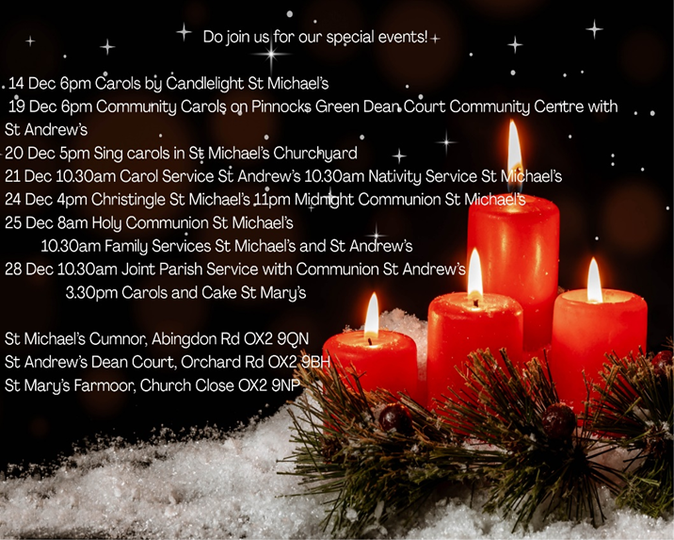

Next Sunday, 28thDecember:
Do join us for our Joint Parish Service with Holy Communion at St Andrew’s at 10.30am.
There are no services in St Michael’s (no 8am service).


St Michael’s Church, Cumnor
Nativity Service
Sunday 21st December 2025

You are all very welcome to our special service today.

Opening prayer

Carol 357: O come all ye faithful (v1,2,6)

Lighting the Advent Candles
The four red candles are lit and we pray together:

Lord Jesus, light of the world,
As we think about Mary and Joseph’s important journey
and your coming to be with us here on earth,
bless everyone preparing for Christmas and to welcome you with us now. Amen.
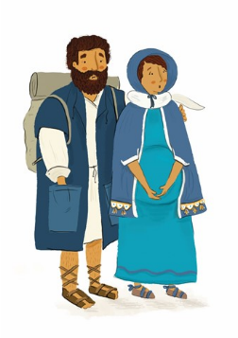
Getting ready for the journey

Joseph and Mary

In Bethlehem

Carol 377: O little town of Bethlehem
In the fields
Coming up ….
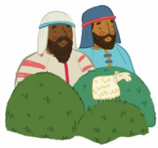
Everyone is welcome to our
Christingle Service
on Christmas Eve at 4pm,
here in St Michael’s.
It will probably last about
40 minutes

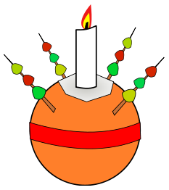
A long way away

Carol 537: We three kings of Orient are (vv 1 & 5 only)

Back home: Jesus’ journey and ours

Carol 51: Away in a manger

Our prayers

Carol 283: Joy to the world

The Blessing


Christmas Day at 10.30am
Christmas Family Service
You are invited to bring a present to show us
and hear about God’s greatest present!

Anyone who would like to is now invited up to the front to form a nativity scene – photos may be taken of this!
